Ad Critique and Redesign — Blackstone Grills

Ad 1: 36" Griddle Bundle — $529

Original Ad
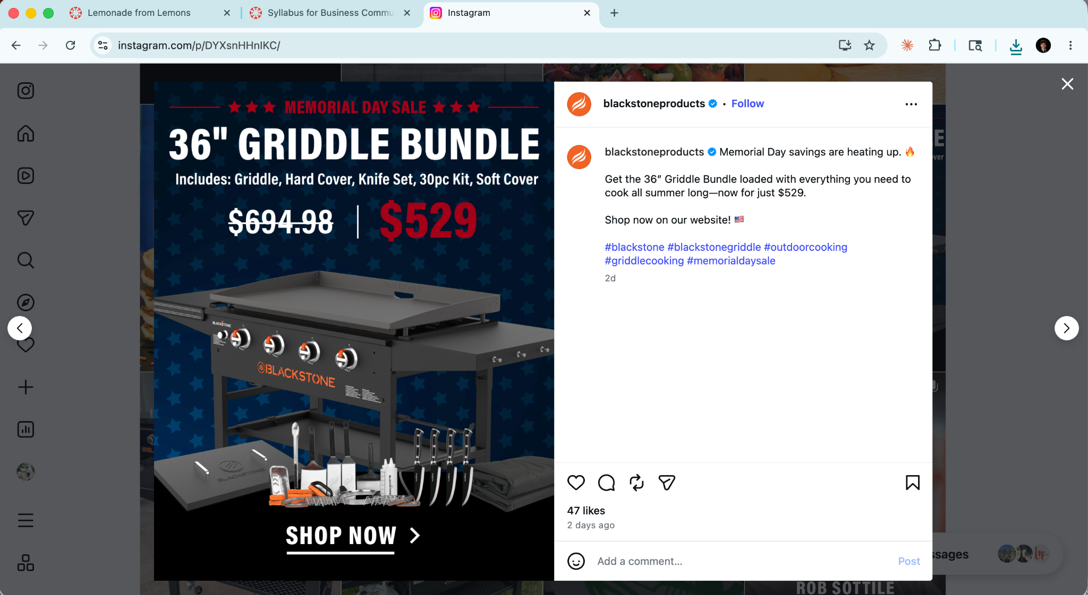

What is wrong with it
The original post leads with a product render on a blue star background, a crossed-out price, and the copy "Memorial Day savings are heating up." At $529, this ad fails to justify the purchase emotionally or rationally. There is no human presence, no scenario, and no answer to the viewer's most basic question: what does my life look like with this griddle? The listed bundle contents — Hard Cover, Knife Set, 30pc Kit, Soft Cover — read like a spec sheet rather than a reason to buy. The CTA "Shop now on our website" is generic and interchangeable with any competitor's post. Nothing in the creative is specific to Blackstone, to this product, or to the person who would actually buy it.

Improved Ad
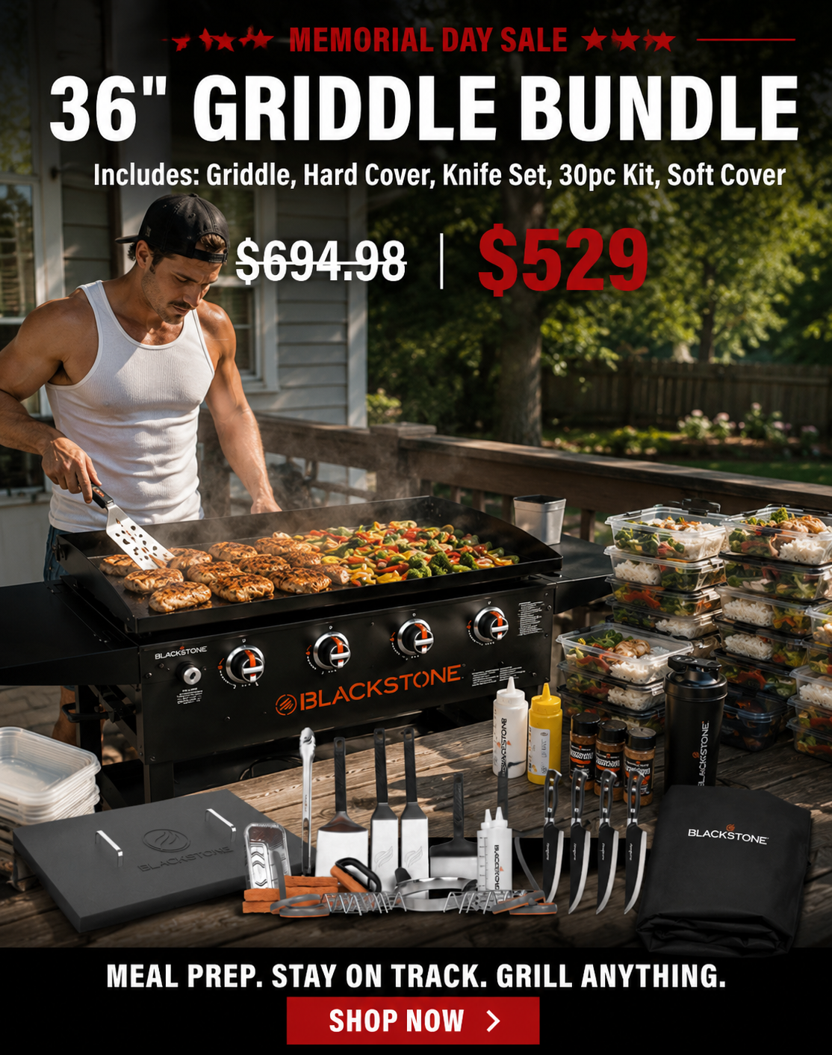

What changed and why it works
The redesigned ad shows a fitness-focused guy in a tank top cooking large quantities of food on the griddle, surrounded by stacked meal prep containers. The tagline becomes "Meal Prep. Stay on Track. Grill Anything." This targets a specific and large Blackstone demographic — gym-goers who cook in bulk — that the original ad ignores entirely. The stacked containers communicate the griddle's scale and productivity without any copy. The tagline connects the product to a lifestyle goal the viewer already has. Price and bundle details remain visible, but now they sit inside a moment the viewer can picture themselves in. The original asks you to buy a product. The redesign gives you a reason to want one.

Ad 2: 28" Griddle Special Edition — $299

Original Ad
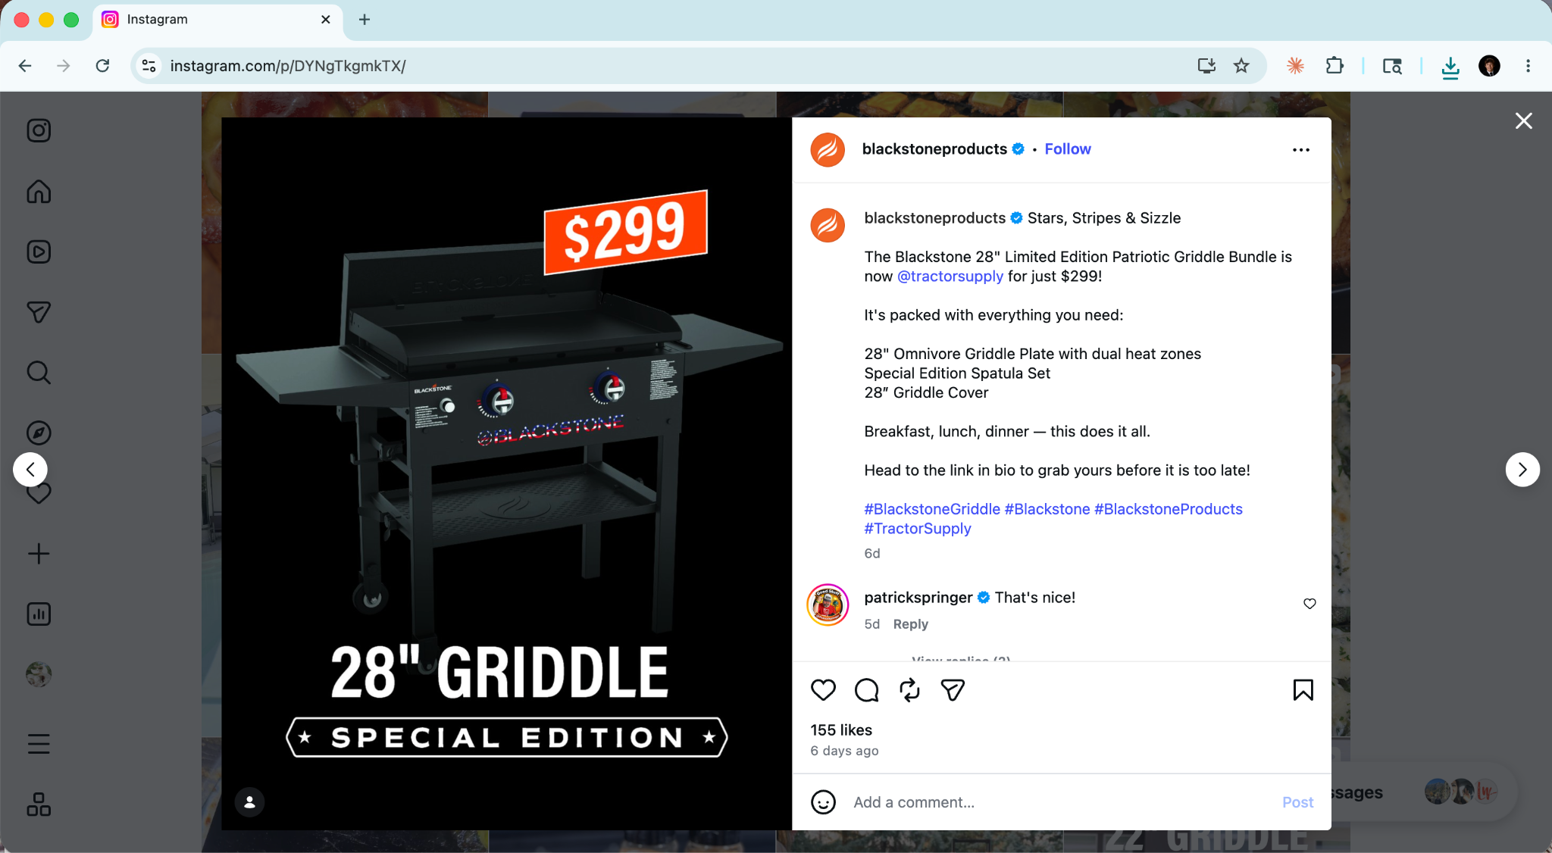

What is wrong with it
The creative is a product render on a plain black background. The only patriotic element is the special edition design on the griddle's knobs — the ad never actually shows a flag, a celebration, or any visual language that earns the Memorial Day moment it's trying to own. The caption lists features like a spec sheet: "28" Omnivore Griddle Plate with dual heat zones / Special Edition Spatula Set / 28" Griddle Cover" — this belongs on a product detail page, not an Instagram ad. "Breakfast, lunch, dinner — this does it all" is technically true but completely generic; every griddle makes all three meals. "Head to the link in bio before it is too late" is hollow urgency that lands flat because nothing in the visual built desire first. Memorial Day is one of the most social, family-centered holidays of the year, and the ad does nothing with that. It could run in October and say the same things.

Improved Ad
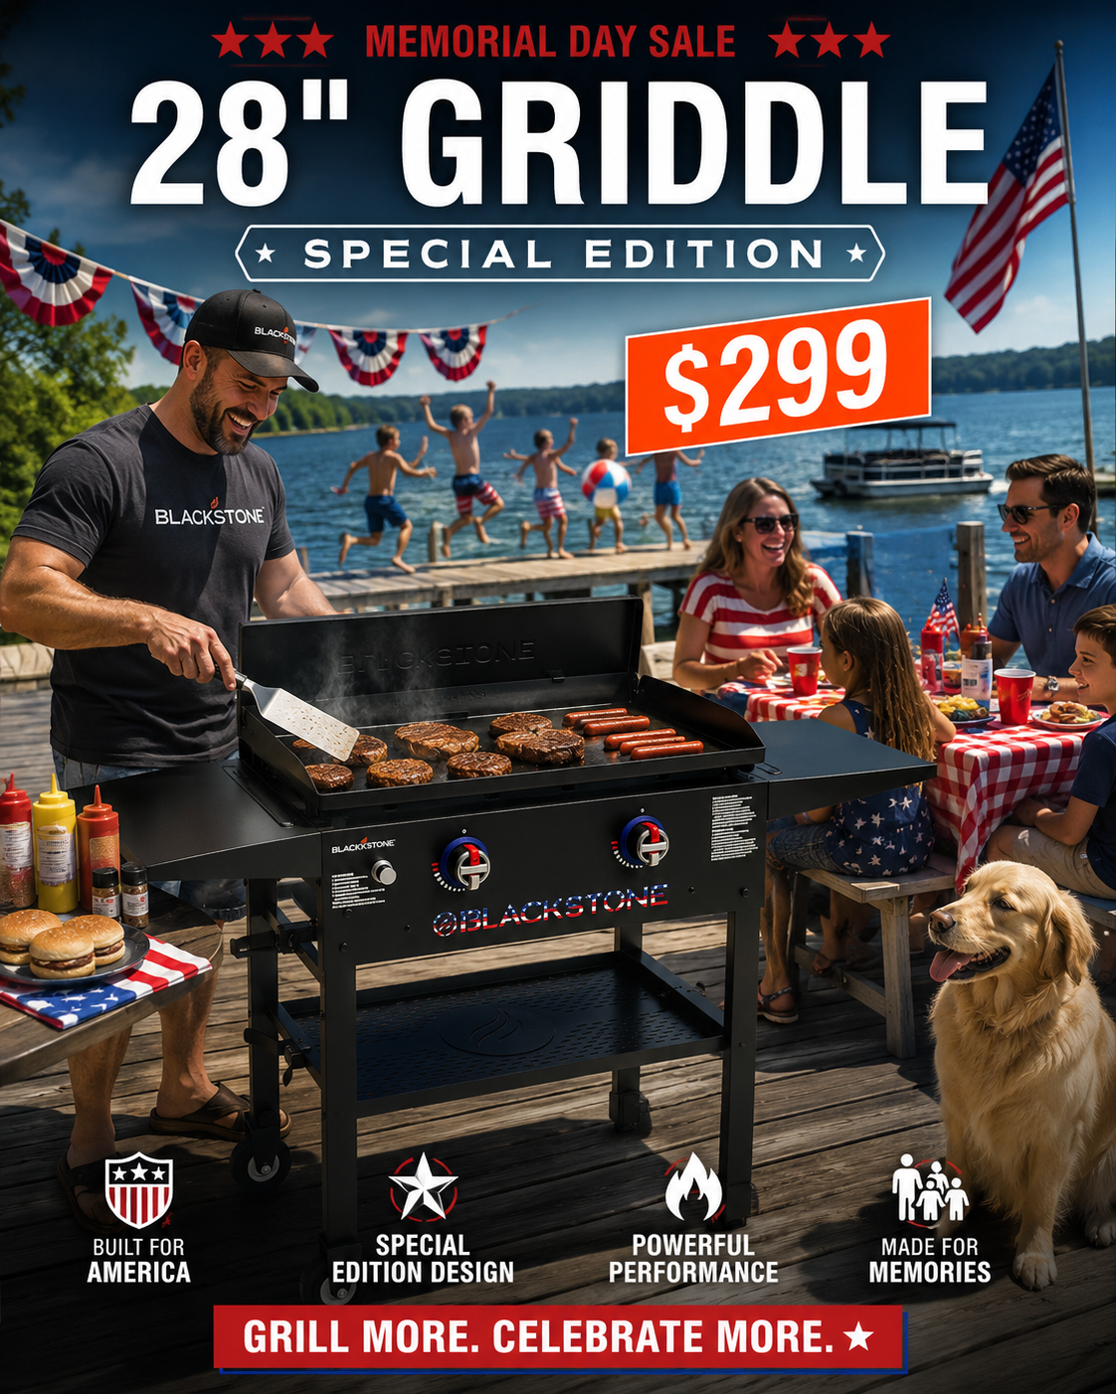

What changed and why it works
The redesigned version delivers on what the original only promised. The scene is a lakeside dock on Memorial Day: kids jumping in the water, a couple laughing, a golden retriever, an American flag, and a griddle loaded with burgers and sausages. The tagline is "Grill More. Celebrate More." The griddle is now part of a memory rather than the subject of an ad, which paradoxically makes people want it more. The patriotic theme is earned — it is a real American scene, not a design applied over a render. Four small badge icons at the bottom cover the product specs (Built for America, Special Edition Design, Powerful Performance, Made for Memories) without cluttering the lifestyle image. "Made for Memories" reframes the griddle as a vehicle for shared experience, which is exactly what Memorial Day is about. The family demographic is Blackstone's core customer. This ad actually talks to them.

Ad 3: 22" Griddle with FlexFold Legs — $299

Original Ad
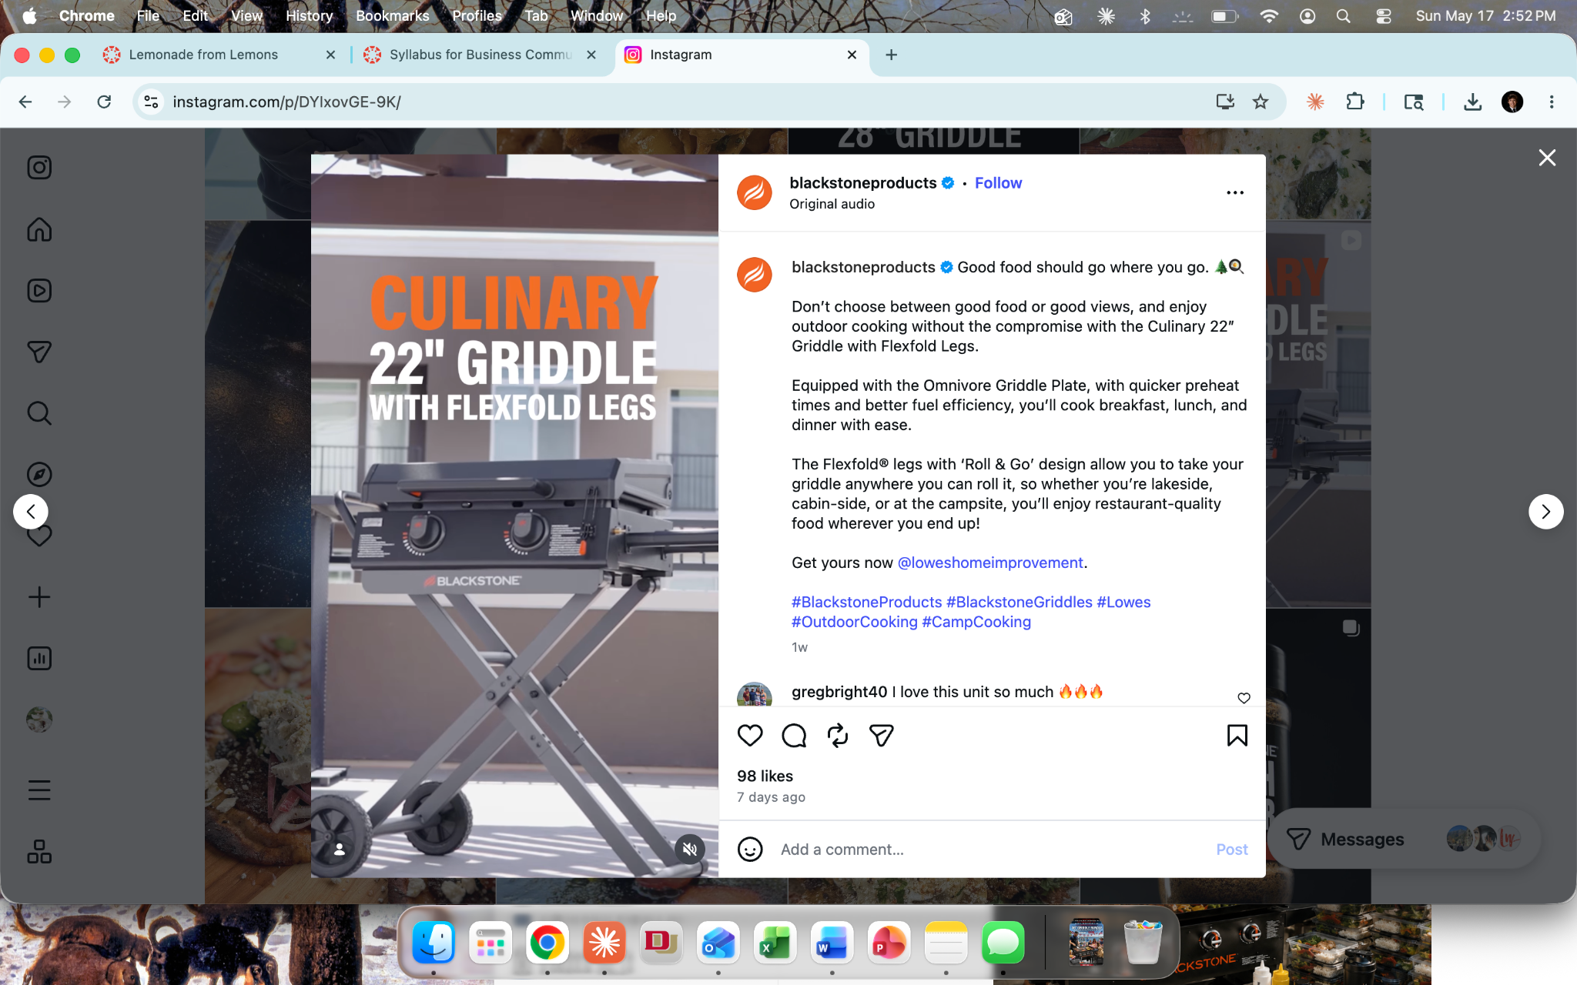
What is wrong with it
The 22" FlexFold is arguably Blackstone's most compelling product for a younger, adventure-oriented audience. The folding legs make it portable, fast to set up, and genuinely built for the outdoors. The creative does almost nothing with this. The thumbnail is a product render with a text overlay reading "Culinary 22" Griddle with FlexFold Legs" — the word "Culinary" reads as cold and corporate for an adventure product. The caption describes features in manual-like language: "Equipped with the Omnivore Griddle Plate, with quicker preheat times and better fuel efficiency." The line "Don't choose between good food or good views" is actually a decent insight, but it is buried in a long caption and the visual never delivers on it — there are no views, no adventure, no outdoors at all. "Get yours now @loweshomeimprovement" sends the viewer off-platform before any desire has been built. The portability story — the entire reason someone buys this griddle instead of the 36" — is completely absent from the creative.

Improved Ad
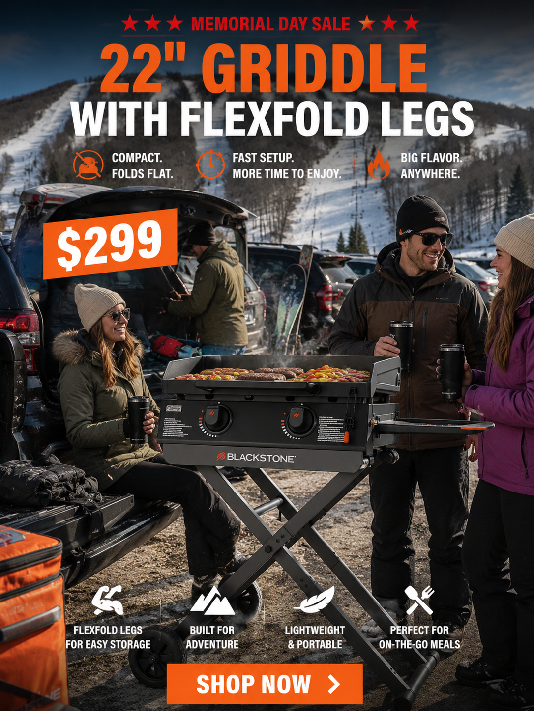

What changed and why it works
The redesigned ad puts the griddle exactly where it belongs: a ski mountain parking lot tailgate. A group of friends in winter gear, steam rising off the cooking surface, a snow-covered peak in the background. Three benefit lines run across the ad: "Compact. Folds Flat. / Fast Setup. More Time to Enjoy. / Big Flavor. Anywhere." This communicates the entire product value proposition in a single scene without a single spec. "Big Flavor. Anywhere." is the sharpest possible expression of what the FlexFold actually is, and the visual proves it. The outdoor and adventure demographic is currently underserved in Blackstone's social creative. This ad opens a new consumer conversation — people who would not typically think of themselves as griddle people but would absolutely bring one to a ski trip (not in may).

